AMDSF: An Agentic Multi-Domain Space Mission Decision Support Framework
Dhivya V.  Department of Computer Science and Engineering  Sri Eshwar College of Engineering  Coimbatore, India | Ms.S.Saradha.  Department of Computer Science and Engineering  Sri Eshwar College of Engineering  Coimbatore, India | Dhanushya T.  Department of Computer Science and Engineering  Sri Eshwar College of Engineering  Coimbatore, India | Devadharsini S.  Department of Computer Science and Engineering  Sri Eshwar College of Engineering  Coimbatore, India

Abstract— Space mission design requires the coordinated assessment of orbital debris, space weather, mission feasibility, and satellite coverage. This paper presents AMDSF (Agentic Multi-Domain Space Mission Decision Support Framework), a web-based multi-agent architecture that integrates four specialized domain agents through a shared mission profile and a central orchestrator. The debris agent retrieves Two-Line Element (TLE) data, performs SGP4 orbital propagation, transforms coordinates using Astropy, and applies KD-tree-based spatial filtering and time-of-closest-approach screening with numerical refinement. The weather agent evaluates space-weather indicators using external data services and rule-based classification. The feasibility agent examines vehicle, payload, orbital, and budget constraints, while the coverage agent provides preliminary estimates of target coverage and revisit characteristics. The orchestrator combines domain-level assessments into a consolidated mission recommendation while preserving human oversight. The framework is demonstrated using a simulation-mode China Earth Observation Mission scenario targeting the Beijing Metropolitan Area. Automated backend tests verify key software functions, including orbital propagation, spatial filtering, and encounter screening. The numerical outputs remain dependent on the underlying data, configured rules, and approximation methods. The paper discusses the implementation limitations and the need for independent domain-specific validation before operational use.
Index Terms-Agentic systems, space mission planning, space situational awareness, orbital debris, space weather, mission feasibility, satellite coverage, multi-objective optimization, multi-agent systems, decision support.
I. Introduction
Modern mission planning requires that decisions be made with regard to a number of technical aspects. An orbit selected for its ability to access a target may also dictate a degree of exposure to conjunctions and a revisit behavior [1], [2], [3]; a launch epoch may meet the needs of an orbital geometry but encounter incompatible space-weather conditions at the same time; and a vehicle configuration that meets the payload requirements may exceed budgetary or mission-duration constraints. When the aspects are analyzed with stand-alone software tools, the same mission assumptions may need to be submitted multiple times and the outcome of analysis in separate domains may not be comparable or reveal conflicts to a final decision-maker. The proposed architecture addresses this integration gap by emphasizing a shared mission context. The planner defines the mission once, four domain agents evaluate that profile independently and an orchestrator combines the returned evidence into an auditable recommendation record. The focus is on traceable integration rather than autonomous mission execution.
The point of this work is to describe an explicit software architecture for preliminary multi-domain mission assessment. This architecture aims to (i) maintain a coherent mission specification across all modules, (ii) expose domain assumptions and outputs as opposed to hiding them in a composite score, (iii) maintain cross-domain conflicts during synthesis, and (iv) provide recommendations that are subject to human review. An additional goal is to distinguish implemented prototype functions from future research components so that simulation-mode demonstrations are not mistaken for validated operational capability.
Unlike conventional approaches that address individual mission domains through separate analysis workflows, AMDSF provides a unified architecture in which specialized agents evaluate a common mission profile. Its primary contribution is the coordination of heterogeneous domain assessments through a centralized orchestrator while preserving the outputs of individual agents. This enables mission planners to examine multiple mission-related conditions, identify potential conflicts, and review consolidated recommendations within a single decision-support environment. The framework builds upon established domain-specific techniques rather than claiming the development of new orbital or environmental algorithms. Its focus is on modular integration, shared mission-context management, and coordinated decision support with human oversight.

The main contributions of the proposed work are:
- Developing a shared mission-context architecture integrating orbital debris, space weather, mission feasibility, and satellite coverage assessments.
- Implementing specialized domain agents with distinct responsibilities and defined assessment outputs.
- Integrating the domain agents through a centralized orchestration mechanism to generate consolidated mission recommendations.
- Implementing a web-based prototype that demonstrates multi-domain mission assessment through a simulation-mode mission scenario.
- Identifying implementation limitations and establishing a validation-oriented direction for future work.
The structure of this paper is as follows. Section II provides a survey of the literature that supports the four problem domains of the analysis and describes the integrated model of multi-agent. In Section III, the mission representation is defined; the end-to-end process is described; agents’ roles and orchestration mechanism; and the application interface. In Part IV report the figures obtained from prototype development; describe the current evaluation strategy; identify the primary limitations. Finally, Part V concludes the paper and outlines the next steps of research.
II. Literature Survey
The literature supporting the architecture can be grouped into five themes: orbital-debris evolution and conjunction analysis; space-weather observation and forecasting; constraint handling and multiobjective optimization; satellite coverage and mission analysis; and agent-based decision systems. The cited works provide foundational knowledge relevant to each agent in the architecture, and the current work attempts to unify all of these contributions in a single mission-support context, rather than proposing new algorithms for propagation, forecasting, or optimization.
The foundational works on orbital debris begin with the observational theories of Kessler and Cour-Palais on breakup-driven collision risk dynamics, and the EVOLVE breakup model for characterizing evolving debris environments [4], [5]. Vallado et al. describe the SGP4 orbital propagation algorithm for TLE-based conjunction analysis [6]. NASA’s own procedures for collision avoidance and probability analysis distinguish between screening processes and the covariance analysis required to assess a realistic probability of collision [4], [9]–[11]; this is important context, as the debris agent described in this paper performs only the screening tasks, without attempting a full dynamic analysis of the uncertainty. In the space-weather domain, Camporeale et al. survey machine learning methods for nowcasting and forecasting, while Bobra et al. and Couvidat et al. evaluate machine learning techniques for solar-flare prediction [10], [11]. Finally, the operational context for space-weather prediction is provided by NOAA SWPC and NASA DONKI, whose human analyst teams represent the rule-based procedures implemented in the current weather-forecasting module [12], [13].
The optimization literature provides a pathway to extending the rule-based feasibility module. Deb and others have developed NSGA-II, a multi-objective evolutionary optimization algorithm; Coello Coello has provided a survey on constraint-handling methods [14], [15]. Research on satellite range-scheduling and constellation-design [16], [17] show the relevance of these methods for space operations. Walker's formulation of constellations and Wertz and Larson's mission-analysis treatment provide the geometric relationship of orbit, access, coverage and revisit [2], [3]. Wooldridge, Jennings, and Russell and Norvig provide foundational concepts on multi-agent and intelligent-agent systems, respectively [18]–[20]. Together, these works provide justification for the architectural choice of specialized agents, connected by a shared mission context. The resulting research gap is primarily integrative; heterogeneous domain results must be consistent, explainable, traceable when presented as one planning workflow.
Ref. | Focus Area | Key Contribution | Relevance to Proposed Architecture
[4], [5] | Orbital debris | Debris growth and breakup environment modeling | Motivates persistent debris awareness
[6] | Orbit propagation | SGP4 propagation and TLE-based analysis | Foundation for current debris agent
[4], [9]- [11] | Conjunction assessment | Screening practice and collision-probability methods | Defines the boundary between screening and operational PC
[10], [11] | Space-weather ML | Forecasting surveys and solar-flare prediction | Motivates future learned forecasting
[12], [13] | Operational weather | NOAA SWPC and NASA DONKI data products | Context for current weather agent
[14], [15] | Optimization | NSGA-II and constraint-handling methods | Basis for future feasibility optimization
[5]- [6], [2]- [3] | Coverage & mission analysis | Scheduling, constellation design, and mission trade-offs | Supports coverage model and future optimization
[18]-[20] | Agent-based systems | Multi-agent and intelligent-agent foundations | Supports shared-context architecture
Table 2.1. Summary of Literature Survey
Research Gap and Architectural Positioning
The reviewed literature establishes the importance of individual techniques for orbital propagation, conjunction assessment, space-weather monitoring, mission feasibility analysis, and satellite coverage estimation. These techniques provide the methodological foundations for their respective mission domains. AMDSF builds upon these established approaches by integrating their assessments within a shared mission-context architecture. The proposed framework connects four specialized agents through a centralized orchestrator, enabling consistent mission inputs, coordinated domain-level outputs, and consolidated recommendations. Its architectural contribution lies in the integration and coordination of heterogeneous mission assessments rather than the introduction of new domain-specific algorithms.
Aspect | Existing Domain-Specific Approaches | AMDSF
Orbital Analysis | Specialized orbital analysis methods | Debris Agent
Weather Assessment | Separate environmental analysis | Weather Agent
Mission Feasibility | Constraint-based assessment | Feasibility Agent
Satellite Coverage | Geometric coverage analysis | Coverage Agent
Mission Context | Domain-dependent inputs | Shared Mission Profile
Assessment Coordination | Domain-level processing | Central Orchestrator
Recommendation | Individual domain outputs | Consolidated Mission Recommendation
Human Review | Application-dependent | Human-in-the-Loop Workflow

Table 2.2. Architectural Positioning of AMDSF

III. Workflow
A mission request is expressed with M = {O, T, L, V, Q, E, B, C}, with O being the mission objective, T the target region, L the launching site or country, V the launch vehicle, Q the orbit, E the target epoch, B the description of the budget and the payload enve- lope, and C other constraints. Four domain functions operate on this shared representation: D(M), debris; W(M), space weather; F(M), feasibility; and G(M), coverage. The mission orchestrator produces a reviewable synthesis R = Oᵣ (D, W, F, G, M). A fundamental design requirement is that L and T be kept as distinct entities; a target region is what the mission is intended to observe and serve, not the location from which it is launched or landed. This distinction allows for exchange of different mission types while preserving the intent of each. The system retains information about the sources, assumptions, domain outputs,es and conflicts, so that the final recommendation is not an inscrutable black box but something that can be reasoned about.
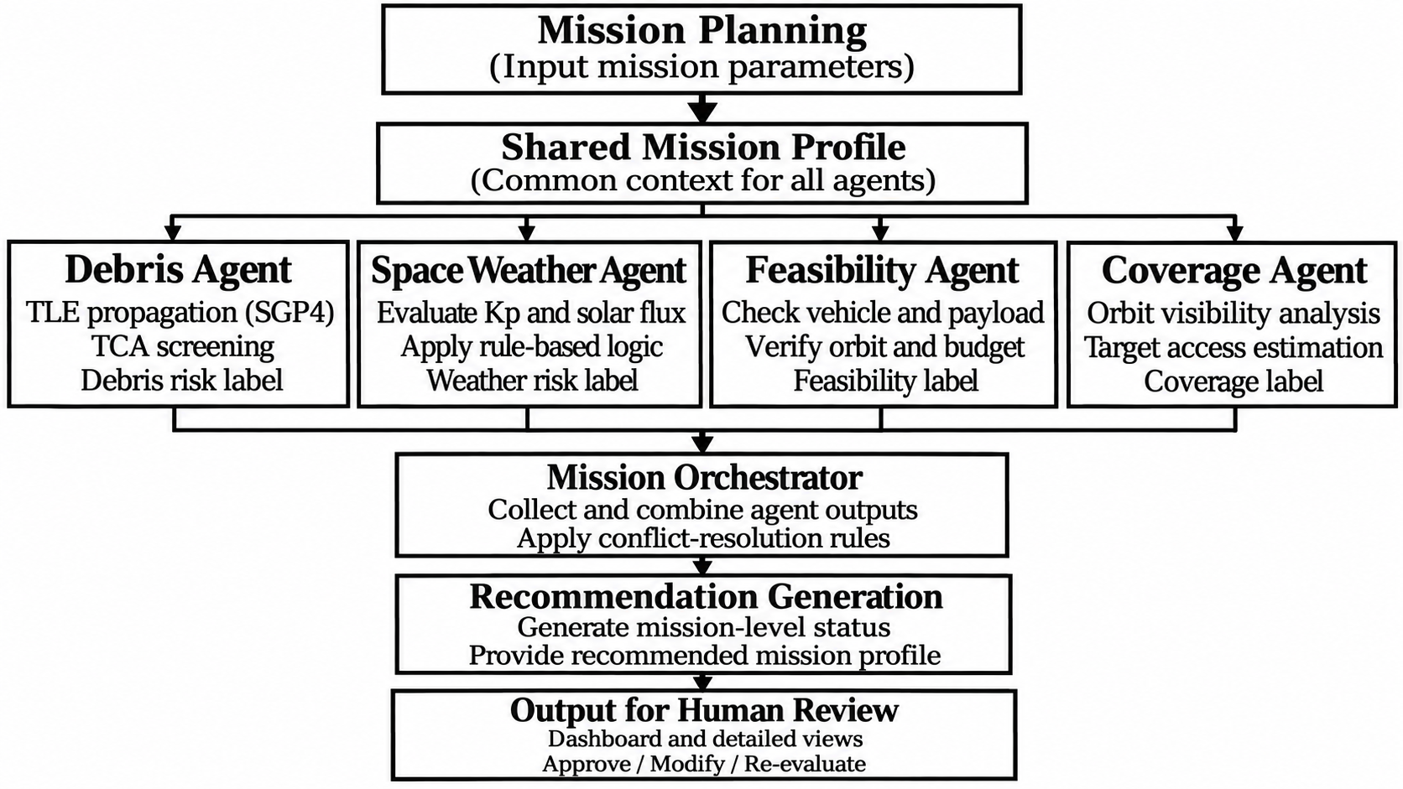
Fig. 3.1. End-to-end workflow of the AMDSF multi-agent decision-support architecture.
The prototype follows the pipeline Mission Planning → {Debris, Weather, Feasibility, Coverage} → Mission Orchestrator → Recommendation. The mission-planning wizard enables the shared flight profile creation, after that all agents consume it and return the structured mission assessments. The debris agent propagates TLE objects via SGP4, applies KD-tree spatial filtering, and time-of-closest-approach algorithm to find the nearby objects and assigns the screening label [4], [6], [9]–[11]. The weather agent classifies the planetary Kp index, solar-flux activity, CME activity and geomagnetic environment using the configured rules and the NASA/NOAA event context [12], [13]. The feasibility agent evaluates the launch-vehicle, payload, orbit and budget constraints and reports a feasible/review state with the cost and mass information. The coverage agent estimates the target access, coverage percentage, coverage gaps, population reach and mean revisit time using the deterministic orbit visibility geometry [2], [3]. Finally, the orchestrator applies the explicit conflict resolution rules to come up with the mission level status, candidate epoch and risk label. The result is a decision-support artifact that does not autonomously launch the spacecraft.

Agent Interfaces and Orchestration Mechanism
The four domain agents operate on a common mission profile while performing separate domain-specific assessments. Each agent processes the relevant mission parameters and returns its assessment to the central orchestrator. The debris agent evaluates orbital-object proximity using TLE-based propagation and spatial screening. The weather agent classifies environmental conditions using available space-weather indicators. The feasibility agent checks engineering and budget constraints, while the coverage agent estimates target accessibility and revisit characteristics. The orchestrator receives these domain-level outputs and applies its coordination logic to generate a consolidated mission recommendation. Individual agent assessments remain identifiable, allowing users to inspect domain-level results and understand their contributions to the final recommendation. Human review remains essential before accepting the proposed mission configuration.

Agent | Input Parameters | Processing Responsibility | Output
Debris Agent | Mission orbit, TLE data | SGP4 propagation, KD-tree filtering and TCA screening | Nearby objects and debris-risk assessment
Weather Agent | Kp, solar flux, CME and geomagnetic indicators | Threshold- and event-based evaluation | Weather-risk classification
Feasibility Agent | Vehicle, payload, orbit and budget | Mission constraint checking | Feasibility status
Coverage Agent | Orbital parameters and target region | Visibility and revisit analysis | Coverage, gaps and revisit estimates
Mission Orchestrator | Outputs from four agents | Rule-based coordination and conflict resolution | Consolidated recommendation
Table 3.1. Functional Responsibilities of AMDSF Domain Agents
The web application has been developed with seven primary views including Dashboard/Mission Operations console, Mission Planning, Debris Intelligence, Space Weather, Mission Feasibility, Coverage Intelligence, and Recommendation. The link to the repository is as follows: https://github.com/dhivya-1010/AMDSF.git . The views are consistent in terms of the mission context. The figures below represent a simulation-mode Earth observation called “China Earth Observation Mission” that could potentially observe the Beijing Metropolitan Area from a 550 km low Earth orbit (LEO), also known as the nominal Indian launch pad. In this case, the target date suggested by the interface was 2026-10-15. Figures 1 and 2 below depict the mission console view and planning while Figs. 3-6 represent the four domain agents. Fig. 7 below represents the synthesized recommendation while Fig. 8 below visualizes the launch-window trade-off. The figures have been captured to explain the interface arrangement and planning processes; therefore, the numerical readings do not necessarily represent actual measurements.
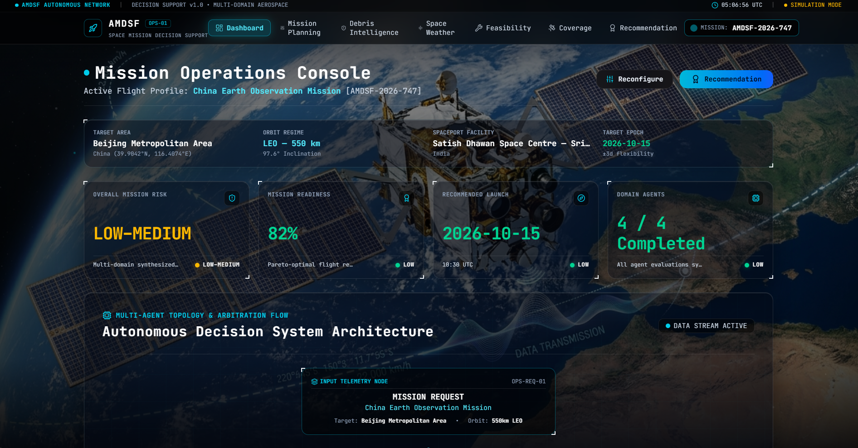
Fig. 3.2. Mission Operations Console showing the shared mission context and synthesized status.
Mission Operations Console provides a single-window view of the mission by graphically displaying the current mission profile with target region, orbit, launch pad, mission risk, readiness, recommended launch date, and completion for each of the domain agents. In addition, the dashboard shows the multi-agent topology and arbitration flow that visually represents how the autonomous decision support system is analyzing the mission domain and combining the analysis to form a recommendation. Using the console, one can view the mission conditions, analyze the results, and make decisions.
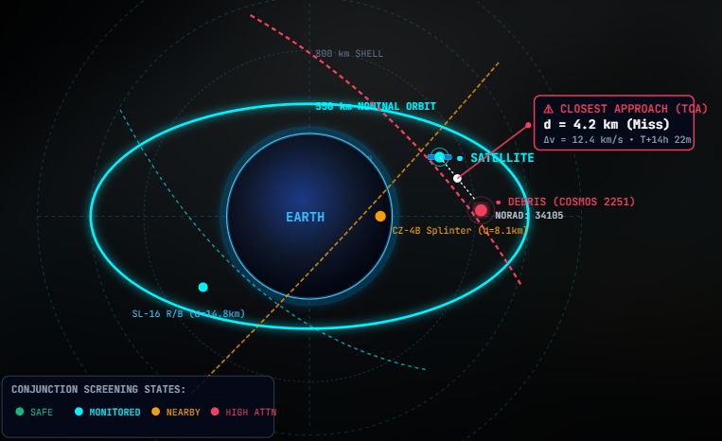
Fig. 3.3. Satellite-debris conjunction risk screening.
The diagram below represents monitoring of the satellite against possible collision with nearby space debris to detect any possible conjunctions. The satellite travels at a 550 km nominal orbit while others such as COSMOS 2251 DEB, SL-16, and CZ-4B are at a much greater distance. Thus, all parameters, such as the time of closest approach (TCA), are stated with a 4.2 km separation and 12.4 km/s speed, indicating debris needing special attention and possible conjunction.
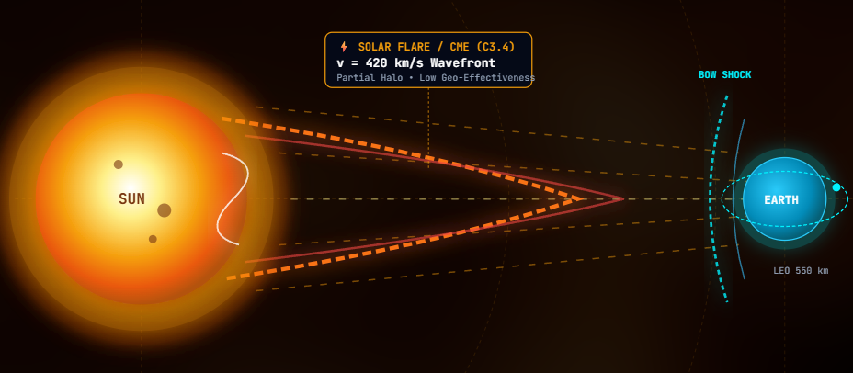
Fig. 3.4. Space-weather agent assesses solar activity and mission weather risk.
The Weather Agent monitors solar flares and CME activity, determines their intensity and potential impact, and assesses any space weather effects that may pose a risk to the mission. It then reports to the Mission Orchestrator its assessment of the weather risk for decision-making purposes.
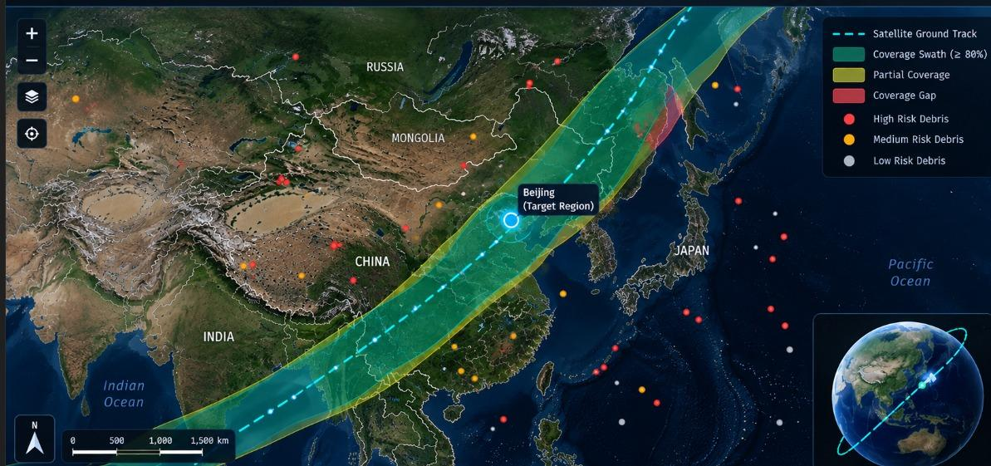
Fig. 3.5. Satellite ground track, coverage swath, target region, and debris-risk zones.
The figure shows the satellite coverage and ground-track analysis for the Asia-Pacific region. It illustrates the satellite orbit track around the Beijing target area, the coverage swath, and regions of possible partial or limited coverage. The image also indicates high-, medium-, and low-risk debris regions, providing an assessment of the target coverage, coverage quality, and possible debris risk.
The study considers ten interconnected capabilities; the first eight are implemented in the current prototype (last two are related to responsible evaluation and decision support):
- A mission specification shared between all views.
- TLE/SGP4 for orbit propagation and screen catalog [6].
- KD-tree filtering and Time of Closest Approach screening for neighboring objects [4], [9]–[11].
- Rule-based monitoring of space-weather events and indicators [12], [13].
- Vehicle, payload, orbit, and budget constraints checking.
- Satellite visibility estimation and target coverage, coverage gaps, and revisit time analysis [2], [3].
- Rule-based coordination of agents and conflict finding between domains.
- Launch window comparison and trade-off visualization.
- Assumptions, explanation, and checkpoints for approval.
- Reproducible data sources, uncertainty accounting, and audit trail.
The main idea is to introduce a shared mission context instead of performing all domain analysis separately. The mission description is defined once and used by all four agents to perform domain analysis. Every agent takes only relevant information, performs a structured analysis, and returns its results to the orchestrator. There is no need to input the same information multiple times as it is used as a single source of information for all domains. The information includes mission objective, region of target, launch location, launch vehicle, payload, orbit, launch time, budget, weather constraints, and coverage requirements.
The shared context can be seen as a mission state M_t, that is updated throughout the process. It includes the user’s mission requirements and every agent’s suggestions and outcomes. For example, debris agent adds conjunction and encounter data, Weather Agent adds space-weather and event data, feasibility agent adds suggestions regarding launch vehicles, payloads, orbits, and budgets. Finally, the coverage agent introduces access, coverage, reach, and revisit information. All the outcomes are combined by the Mission Orchestrator and a conclusion with the recommendation is provided based on the mission constraints.
A major aspect of the described architecture is traceability, since every recommendation can be traced back to the domain results that produced it. Instead of simply providing scalar values, the domain returns a chain of evidence, forming the following sequence: input parameter → domain calculation or rule → domain status → cross-domain trade-off → recommendation. This is particularly valuable during the preliminary design phase, since the results of a domain can be reviewed without recomputing the entire workflow.
For preliminary assessment, the mission can be seen as a constrained multi-objective problem, where x represents the decision variables to be optimized, including orbital parameters, candidate launch time, vehicle type, and other configurable mission parameters. The system considers four objective functions, representing debris exposure, weather suitability, mission feasibility, and coverage performance, F(x) = [f_d (x), f_w (x), f_f (x), f_c (x)]. The current implementation does not pursue global optimization over the search space. Instead, these values are utilized to implement rule-based screening and comparison of alternative candidates [14], [15].
The debris component utilizes a screening criterion based on the tracks of propagated space objects and a user-defined distance threshold. For each space object, the minimum distance to the mission spacecraft is calculated over the analysis period, and only those objects that satisfy the screening criterion are used for conjunction assessment. This allows a fast first-pass screening, and acknowledging that an actual conjunction assessment requires uncertainty information and collision probability calculations [4], [9]–[11].
The weather component utilizes threshold- and event-based rules. The agent uses environmental information provided as input and classifies it (nominal, watch, or adverse) based on the specified thresholds. The results of this classification should not be interpreted as a weather forecast per se but are instead used as a simple screening criterion based on data and thresholds provided in the prototype [12], [13]. This becomes particularly useful if the system is used with simulated or old data.
Space-Weather Data Sources and Assessment Criteria
The space-weather agent evaluates environmental conditions using data obtained through the NOAA Space Weather Prediction Center (SWPC) and NASA Space Weather Database of Notifications, Knowledge, Information (DONKI) services. The assessment uses available planetary Kp index information and coronal mass ejection (CME) event data to classify environmental risk. In the current implementation, a Kp value of 6 or higher results in a high-risk classification. A Kp value of 4 or higher, or the presence of at least three CME events, results in a medium-risk classification. Other evaluated conditions are classified as low risk. These classifications represent rule-based assessments of available environmental data rather than statistically validated space-weather forecasts. The assessment is also dependent on data availability, source timestamps, and fallback handling.

Indicator | Information Evaluated | Assessment Method
Planetary Kp Index | Geomagnetic activity level | Threshold-based classification
CME Events | Number of detected coronal mass ejection events | Event-count-based classification

Table 4.3. Space-Weather Assessment Parameters
The feasibility aspect evaluates the main constraints and preferences of the mission. The candidate is deemed as feasible when the required vehicle capability, payload compatibility, orbit requirements, and budget conditions are met. Coverage is taken as a performance factor, not simply as a yes/no condition. Therefore, target access, coverage gaps, spatial reach, and revisit behavior can be compared between different mission profiles [2], [3].
Mission Feasibility Evaluation Criteria
The mission feasibility agent evaluates the compatibility of the proposed mission configuration with the specified engineering and budget constraints. Vehicle capability is considered in relation to the mission's launch and orbital requirements, while payload compatibility is assessed based on the required payload characteristics and available vehicle capacity. Orbital parameters are examined against the configured mission requirements, and the estimated lifecycle cost is compared with the available budget constraint. Based on these assessments, the agent reports a feasibility status indicating whether the specified conditions are satisfied or require further review. Coverage performance is considered separately as an additional mission-performance factor rather than being treated as an independent feasibility condition. The resulting assessment depends on the completeness and accuracy of the mission inputs and configured constraint information.
Parameter | Evaluation Criteria | Assessment Purpose
Launch Vehicle | Vehicle capability and mission requirements | Vehicle compatibility
Payload | Payload requirements and vehicle capacity | Payload compatibility
Orbital Parameters | Required orbit and configured constraints | Orbital suitability
Budget | Estimated lifecycle cost and available budget | Cost feasibility
Table 4.4. Mission Feasibility Assessment Parameters
The prototype is realized as a web-based decision support application, in which the domain processing modules are combined with an orchestration layer. The interface provides the user with the main point of interaction, whereas the analytical agents process the shared mission context. The process begins with the mission-planning wizard, which validates the request and constructs a standardized mission profile. The orchestrator then conveys the message to the different domain modules, which collate their outputs, and present their finding in a consolidated status view.
For orbital screening, Two-Line Element (TLE) data are propagated using the SGP4 approach described in the literature [6]. A spatial filtering stage, implementing KD-tree proximity analysis, is applied to reduce the number of objects subject to time-based inspection. The resulting encounter records may carry with them object identifiers, closest-approach time, relative separation and screening status. The purpose of this process is to provide fast preliminary awareness rather than to substitute to specialized operational conjunction assessment systems.
Orbital Data Configuration and Debris Screening Procedure
The debris assessment module retrieves Two-Line Element (TLE) records from the CelesTrak data service and validates the records before orbital propagation. The SGP4 algorithm, implemented using the Python sgp4 library, propagates the mission satellite and catalogued objects over multiple UTC timestamps. The resulting TEME position and velocity vectors are transformed into the International Terrestrial Reference System (ITRS) using Astropy to maintain a consistent coordinate frame for spatial analysis. A KD-tree-based filtering stage, implemented using scipy.spatial.cKDTree, identifies candidate nearby objects at corresponding propagation timestamps. For the retained candidates, relative position, separation distance, and relative velocity are calculated. The sampled minimum-separation epoch is further refined using bounded numerical minimization to estimate the time of closest approach (TCA). The resulting encounter records support preliminary conjunction screening and risk classification. This implementation does not perform covariance-aware collision probability estimation and is not intended to replace operational conjunction assessment systems.
Parameter | Configuration / Description
TLE Data Source | CelesTrak General Perturbations (GP) data service
TLE Validation | Format and checksum validation
Propagation Method | SGP4
SGP4 Implementation | Python sgp4 library
Coordinate Transformation | TEME to ITRS using Astropy
Time Standard | UTC
Spatial Filtering | KD-tree using scipy.spatial.cKDTree
TCA Calculation | Sampled minimum separation with bounded numerical refinement
Relative Separation | Euclidean distance in kilometres
Relative Velocity | Calculated from propagated velocity vectors in km/s
Table 4.2. Orbital Debris Assessment Configuration
For space-weather processing, the system takes environmental indicators information and encodes them into simplified application-level states [12], [13]. External data sources may be integrated without impacting the mission-planning interface, since the agent handles source-specific processing in isolation. Likewise, vehicle and cost information may be retained in structured assumption form, enabling efficient revisits of the feasibility decision in the event of underlying data updates.
Coverage processing tests whether the chosen orbit can access the target region under the given set of conditions. The result encodes multiple metrics, not just one aggregated value. There are cases where a candidate may appear to have high geographic coverage, but exhibit large access voids or long revisit time, which could be critical for the mission. Individually weighing such factors will allow the orchestrator to detect any hidden incompatibilities that a single percentage value would conceal [2], [3].
Satellite Coverage and Revisit Estimation
The coverage agent evaluates satellite accessibility to the specified target region using deterministic orbital geometry. The assessment considers the mission orbital configuration and the geometric relationship between the satellite ground track and the target region. Target visibility is evaluated over the selected analysis interval to identify access opportunities. Revisit time is estimated from the time intervals between successive target-access opportunities, while coverage gaps indicate portions of the target region that are not accessed under the selected mission configuration. Population reach is estimated using the population information associated with the target region and the implemented coverage-assessment procedure. These estimates depend on orbital parameters, sensor geometry, target-region representation, and the availability of population data. The resulting values are preliminary simulation outputs and require independent comparison against an established coverage-analysis reference before being considered validated.
Parameter | Description | Assessment Purpose
Orbital Parameters | Satellite altitude and orbital configuration | Determine satellite trajectory
Target Region | Geographic area selected for observation | Define coverage area
Sensor Geometry | Configured observation geometry | Determine target visibility
Ground Track | Satellite trajectory over Earth's surface | Identify access opportunities
Coverage Gaps | Areas without estimated access | Identify observation gaps
Revisit Time | Time between successive access opportunities | Evaluate observation frequency
Population Data | Population information associated with target region | Estimate population reach
Table 4.5. Satellite Coverage Assessment Parameters
The architecture was designed to support the decision-making process, not to dictate mission authorizations through automation. Human approval is required both when defining the candidate set and when recommending a specific mission plan. This allows a human engineer to tweak assumptions, reject a candidate, or reevaluate the supporting domain results before the launch window is finalized. This is especially valuable when incomplete inputs, conflicting constraints, or an out-of-context rule produce unacceptable results.
The explanation layer is thus a vital component of the system, where for each recommendation it is useful to weigh the supporting factors, assumptions, and uncertainties. A candidate may fit within the vehicle and payload constraints but appear to have higher debris risk and lower target access during a specific temporal segment, which will have to be evaluated by the mission analyst. Instead of an automated final score, such scenarios should be resolved by presenting the trade-offs between different metrics.
The human-in-the-loop design is also beneficial for reproducing results, should the launch time or orbital altitude be modified. The same mission context may be reloaded with new constraints, and the agents may be rerun to produce the updated analysis. In future iterations, such processes may be supported by experiment IDs, data timestamps, configuration hashes, and machine-readable audit trails.
IV. Results and Discussion
Table II contains selected values which may be observed in the supplied prototype interface. These values are provided for descriptive purposes only, and the application is labeled SIMULATION MODE.

Interface Metric | Value | Qualification
Mission readiness | 82% | Aggregated mission readiness indicator
Domain agents completed | 4 / 4 | Domain-agent execution status
Overall mission risk | Low–Medium | Integrated mission risk classification
Debris catalog objects analyzed | 8420 | Catalog screening count
Nearby orbital objects | 12 | Nearby-object screening count
Displayed debris risk score | 0.52 | Normalized debris risk indicator
Planetary Kp index | 3.2 | Planetary geomagnetic activity index
Feasibility status | Feasible | Rule-based mission feasibility assessment
Estimated lifecycle cost | $16M | Estimated mission lifecycle cost
Payload wet mass | 250 kg | Configured payload parameter
Target coverage | 97% | Estimated target-area coverage
Estimated population reach | 8.8M | Estimated population coverage
Coverage gaps / mean revisit | 1 / 110 min | Coverage and revisit indicators
Suggested launch epoch | 2026-10-15, 10:30 UTC | Recommended launch epoch

Table 4.1. Selected Stimulation-Mode Interface Values
The 97% target-coverage value reported in Table 4.1 represents the estimated coverage output for the specific simulation-mode China Earth Observation Mission scenario. It is a scenario-specific interface estimate and should not be interpreted as a general coverage-performance metric or an independently validated measurement.
Interpretation of Mission-Level Dashboard Outputs
The mission-level dashboard presents assessment outputs generated for the selected mission configuration. The displayed mission-readiness value of 82% represents a scenario-specific readiness indication, while the debris-risk score of 0.52 represents the corresponding debris assessment output. Similarly, the estimated target coverage of 97% and population reach of approximately 8.8 million describe the coverage assessment for the selected target region. These values are specific to the China Earth Observation Mission demonstration scenario and should not be interpreted as general model-accuracy measurements or universally applicable performance indicators. Their interpretation depends on the mission inputs, configured assessment rules, and underlying data used by the respective agents. Independent verification and documented calculation procedures are required before these outputs can be considered validated engineering measurements.
The supplied material does not contain frozen input datasets, execution logs, timestamps for each value's source, or independent validation metrics; accordingly, the values should not be considered to represent accuracy, safety, or global mission optimization. The dashboard also provides a comparative launch-window visualization that contains relative indicators for the conjunction risk, operational cost, target coverage, and safety. Due to the candidate-generation approach, normalization process, and the input data used, this visualization should be regarded as a mere user-interface demonstration of multi-objective comparison rather than an indication of a global optimum in the displayed epoch.
The current material does not include controlled experimental results. Accordingly, this paper cannot make claims about improved run-time performance, prediction accuracy, collision-probability calibration, weather-forecast skill, optimization convergence, global optimality, or operational readiness. A proper evaluation would require freezing the data sets used, with URLs, time stamps, frames of reference, and algorithmic parameters ; comparing the SGP4 propagation and screening against trusted implementations [6] ; evaluating the weather-classification performance on independent data sets with respect to precision, recall, calibration; testing the feasibility check on explicit feasible and infeasible data against mathematical benchmarks; comparing the coverage geometry against an independent simulator; and testing the overall system for cross-agent coherence, repeatability, provenance, and traceability of explanations.
•The interface is explicitly marked simulation mode; displayed values are not independently verified experimental measurements.
• TLE/SGP4 propagation with KD-tree screening and TCA does not provide a covariance-aware operational probability-of-collision assessment [4], [9]–[11].
• Rule-based weather classification is not a statistically trained forecast and depends on configured thresholds and data freshness.
• Feasibility conclusions depend on the completeness and currency of vehicle, payload, orbit, and cost assumptions.
• Coverage estimates are sensitive to orbit parameters, sensor geometry, target boundaries, elevation masks, sampling, and population data.
• Rule-based orchestration keeps priorities inspectable but does not establish global optimality or calibrated mission risk.
• A functional web interface demonstrates workflow integration but does not by itself establish scientific validity or operational reliability.

A complete evaluation of the proposed architecture should combine software-level verification with domain-specific validation. The former should employ unit tests to verify mission-profile parsing, parameter propagation, coordinate handling, threshold evaluation, and the aggregation of outputs produced by the agents. Integration tests should ensure common mission identifiers and configuration are consistent across the four domain agents, and regression tests should verify unrelated domains are not affected by changes to a single module.
At the analytical level, each agent should be assessed against an appropriate reference or controlled test case. Debris propagation can be validated by comparing generated states against independently computed SGP4 states for controlled orbital objects. Conjunction screening can be evaluated using synthetic trajectories with analytically known closest-approach conditions, and weather classifications compared against timestamped source observations under a fixed threshold configuration. Similarly, coverage calculations can be evaluated using predefined geometries for which access intervals and revisit characteristics can be independently determined.
The evaluation should also consider the computational behaviour of the framework; relevant measures include end-to-end execution time, agent latencies, number of debris objects processed, number of candidate encounters retained, memory usage, and sensitivity to increasing catalog size. Since AMDSF is intended to support interactive decision-making, latency measurements should always be reported alongside the corresponding workload and hardware environment rather than being presented as isolated performance values. To ensure reproducibility, the software version, input dataset, configuration parameters, and execution environment should be recorded for every benchmark.

Scenario | Test Configuration | Evaluation Objective
S1 – Baseline Mission | Nominal mission parameters | Verify normal agent execution
S2 – Dense Debris | Increased orbital-catalog size | Evaluate debris-screening behavior
S3 – Adverse Weather | Adverse environmental indicators | Verify weather classification
S4 – Restrictive Feasibility | Modified payload or budget constraints | Evaluate feasibility decisions
S5 – Coverage Variation | Modified orbit or target region | Evaluate coverage and revisit estimates

Table 4.6. Proposed Experimental Scenarios for AMDSF Evaluation
The proposed evaluation scenarios provide a structured basis for assessing the behavior of the four domain agents under different mission conditions. Each scenario is intended to modify specific mission parameters while maintaining the remaining inputs consistently, enabling the effects of individual changes to be examined. The evaluation should consider domain-specific correctness, consistency of agent outputs, repeatability of recommendations, and the ability to identify conflicting mission constraints. These scenarios represent a proposed evaluation protocol and are not reported as completed experimental results in the current prototype study.
Performance Metric | Evaluation Method | Purpose
End-to-End Execution Time | Measure total workflow execution time | Evaluate overall response time
Agent Execution Time | Record individual agent processing time | Identify computational bottlenecks
Memory Consumption | Measure memory usage during execution | Evaluate resource requirements
Catalog Processing | Record number of orbital objects processed | Assess debris-processing workload
Candidate Encounters | Count objects retained after spatial filtering | Evaluate screening effectiveness
Scalability | Repeat tests with increasing catalog sizes | Examine scaling behaviour
Repeatability | Execute identical scenarios multiple times | Check consistency of outputs
Table 4.7. Performance Metrics for AMDSF Evaluation
The performance metrics provide a basis for evaluating the computational efficiency and scalability of AMDSF. Execution time and memory consumption should be measured under a controlled environment using consistent mission configurations and increasing orbital-catalog sizes. Individual agent latencies and end-to-end execution time can help identify processing bottlenecks, while the number of retained candidate encounters indicates the workload reduction achieved during debris screening. Repeated executions using identical inputs can further assess the consistency of the generated outputs. These metrics define the proposed benchmarking methodology; quantitative performance results are not established in the current simulation-mode demonstration.
Human factors should be assessed independently from numerical correctness. Mission engineers should be able to identify the assumptions underlying a recommendation, trace individual warnings to their originating agents, and determine how the recommendation changes when mission parameters are modified. A future user study can therefore examine task-completion time, error identification, explanation comprehension, and decision consistency across controlled scenarios.
Although the current prototype is positioned as a research demonstrator, extending its use towards operational would require stronger controls for data provenance and configuration management. Mission inputs, catalog timestamps, external data sources, threshold configurations, and software versions should be recorded for every analysis. This would allow subsequent reviewers to reconstruct the information and configuration available when a recommendation was generated. This is particularly important when external space-weather or orbital datasets are updated after an analysis has already been performed.
The system should also maintain a clear distinction between authoritative inputs and derived outputs. Raw source measurements and catalog records should be separated from propagated states, filtered encounters, classifications, and recommendation text. This will allow upstream data sources to be replaced without modifying the underlying analytical logic, and reduce the possibility of a derived status being mistaken for an original observation.
Conventional preliminary mission studies often divide analysis into domain-specific activities performed using separate tools or by different teams. Such workflows can provide detailed specialist analysis, but require mission assumptions to be repeatedly transferred between tools. The proposed architecture addresses this integration challenge by maintaining a common mission context and explicitly connecting the outputs generated by each domain. The contribution is therefore primarily architectural and workflow-oriented; it does not claim novelty for the individual propagation, weather, feasibility, or coverage algorithms considered independently.
The agent-based formulation also provides a pathway for incremental refinement. Individual domain modules can be replaced with higher-fidelity implementations while maintaining the shared mission context and orchestration interfaces. For example, a future conjunction-analysis module could incorporate covariance-aware probability-of-collision calculations without requiring a redesign of the mission-planning interface. Similarly, a statistical space-weather model could replace the existing rule-based classifier while maintaining the same output structure containing status, evidence, timestamp, and uncertainty.
This modularity also supports research reproducibility; improvements can be introduced and evaluated one agent at a time against the preceding implementation. Consequently, the proposed architecture can function as an experimental platform for comparing alternative algorithms under consistent mission scenarios, rather than as a fixed application in which individual analytical components cannot be independently replaced.
For research use, the prototype can be exercised using a fixed set of representative mission scenarios. Each scenario defines the same core mission profile, but varies a controlled parameter (such as orbit altitude, inclination, candidate epoch, target region, payload class, or budget limit) in order to separate the behavior of the architecture from uncontrolled changes in the mission scenario. This approach also enables a comparison of the response of the four agents under repeatable conditions.
A baseline scenario serves to ensure that all four agents receive the same mission identifiers and parameters. Additional stress scenarios can be generated by a dense orbital catalog, adverse environmental indicators, a restrictive payload constraint, a demanding coverage requirement, or other means. The expected mission result may not be feasible, but the system should correctly expose the constraint or conflict that precludes a candidate from satisfying the configured requirements.
Parameter-sensitivity experiments can help identify discontinuities introduced by rule thresholds. For example, a small change to an environmental indicator near a configured boundary may toggle the weather status from nominal to watch. Recording the input value and the resultant classification allows researchers to determine if the threshold behavior is intentional and whether the interface communicates the change clearly. Similar tests can be made for debris screening distance, budget limits, payload compatibility, and coverage thresholds.
The same scenario framework can also be used to compare rule-based and learning-based agents. A learning-based replacement receives the same normalized mission context and produces output through the same interface contract. The researcher can therefore compare the accuracy, latency, explanation quality, and sensitivity in a controlled manner without modifying the surrounding application. This represents a controlled pathway for introducing machine-learning components while retaining the transparency of the current rule-based architecture.
An important reporting principle ensures that the distinction is maintained between a demonstration result and a validated scientific result. Interface percentages, readiness indicators, and status labels are useful for demonstrating data flow and user interaction, but are subject to misinterpretation if the supporting datasets, ground truth, and evaluation protocol are not documented. The present paper therefore focuses on the prototype as an architectural proof of concept, and identifies the validation steps needed before operational claims can be validated.
A decision-support system for space missions must distinguish between uncertainty in the physical environment and uncertainty caused by incomplete information. The current prototype exposes the distinction explicitly by its exposure of assumptions and qualification of results in simulation mode. In a future implementation, each domain output can carry an uncertainty descriptor in addition to its nominal value. For example, a debris-screening result can include the propagation interval and catalog age, while a coverage result can include the sampling interval and assumed elevation mask.
These uncertainties should be brought out in the explanation rather than masked from the user, such that if the catalog is out of date, the user knows that it is a debris assessment based on a dated set of tracked objects, or if the weather data is delayed, it is obvious when looking at the interface that the timestamp denotes an observation, not a proposed launch time, etc. These are additional degrees of uncertainty that would be relevant in a feasibility study: variations in the launch cost, differences in the expected mass of the payload, or the potential unavailability of the indicated launch vehicle. A clear statement of these conditions prevents the user from mistakenly interpreting a tentative software assessment as an assurance of mission success.
This principle could be extended to incomplete information by keeping track of the assumptions that have been made in cases where the orchestrator was forced to apply a default value. By allowing the user to confirm these assumptions prior to conducting a final comparison of candidate missions, we would be able to ensure a safer interaction: the user would be able to differentiate between parameters that were provided, inferred from the configuration, or unavailable. This also separates deterministic computations that are performed by the software from decisions that ultimately belong to the mission designer.
The modular design also enables the number of mission scenarios as well as the number of analytical modules to scale independently. Scenario-level parallelism can be exploited by analyzing candidate launch epochs or orbital configurations in parallel, as long as the domain agents operating on them have access to a shared mission context. The orchestrator can then aggregate results of these tasks asynchronously to a shared mission identifier.
Scalability is of particular concern for analyzing debris, as the number of potential objects in the space catalog can be large. Processing this space catalog can be optimized by first applying coarse spatial filtering, followed by time-of-closest-approach screening, thus reducing the number of pairwise comparisons required. The current prototype identifies KD-tree filtering for this purpose. The current prototype can be expanded in future work to other approaches such as alternate indexing schemes, batch orbit propagation, caching of repeated states, distributed execution, and more, depending on the growth of the catalog and the analysis period.
The scalability considerations would also need to affect the data layer, as external space-weather feeds, orbital catalogues, vehicle databases, and target datasets might have incompatible update schedules or data representations. By normalizing the internal representation of this data, the individual agent could be made resilient to updates to its source adapters. This would decouple the source-specific updates from the rest of the processing pipeline, and would also enable experimenting with replacing one source by another.
Finally, a reproducible record for a mission analysis would need to capture not just the mission profile and input datasets, but also timestamps, configuration parameters, version identifiers of the software, agent outputs, and recommended text. The current prototype focuses on explicit assumptions and human-readable explanations. The principles could be expanded to also capture a machine-readable audit trail by identifying corresponding information for each agent execution, such as input identifiers, processing status, derived metrics, warnings, and data lineage.
The audit trail would also help in diagnosing computational failures. If one agent returns an unexpected result, the orchestrator could use the trail to distinguish between an input anomaly, an error in the agent calculation, a threshold configuration issue, or an aggregation rule anomaly. This would be an improvement on the current practice of reading a final status from a dashboard. In both cases, the intermediate evidence would be available for manual inspection. In a research activity, this could take the form of a citing record, when limitations of a scenario are discussed or when a scenario is excluded from a quantitative evaluation.
V. Conclusion and Future Work
This paper presented a unified agentic architecture for preliminary multi-domain space-mission decision support. The current prototype unifies TLE/SGP4 debris screening, rule-based space-weather assessment, engineering and economic feasibility checking, deterministic coverage geometry, and rule-based mission orchestration under the same mission profile. The interface demonstrates how heterogeneous evidence may be combined into a single reviewable workflow while maintaining domain assumptions. The primary value of the present implementation lies in the architectural integration and traceability; the values displayed in the simulation do not establish scientific or operational validity.
The authors advise that it is the right sequence for future development to enter a validation-first sequence. The first stage should establish reproducible datasets, automated integration tests, source provenance, and reference implementations for every agent. Subsequent algorithmic extensions may incorporate covariance propagation and Monte Carlo probability-of-collision estimation for debris [9]–[11], XGBoost-based weather forecasting with time-aware validation [10], [11], NSGA-II multi-objective feasibility search [14], [15], population-weighted coverage optimization [5]–[6], [2]–[3], and Pareto-based orchestration to expose non-dominated mission alternatives. The checkpoints that has to be approved by humans and the decision logs should be a part of the architecture.
REFERENCES:
[1] NASA, "Spacecraft Conjunction Assessment and Collision Avoidance Best Practices Handbook," NASA, 2023.
[2] J. G. Walker, "Satellite constellations," Journal of the British Interplanetary Society, vol. 37, pp. 559–572, 1984.
[3] J. R. Wertz and W. J. Larson, Eds., Space Mission Analysis and Design, 3rd ed. Torrance, CA, USA: Microcosm Press, 1999.
[4] D. J. Kessler and B. G. Cour-Palais, "Collision frequency of artificial satellites: The creation of a debris belt," Journal of Geophysical Research, vol. 83, no. A6, pp. 2637–2646, 1978.
[5] N. L. Johnson, P. H. Krisko, J.-C. Liou, and P. D. Anz-Meador, "NASA's new breakup model of EVOLVE 4.0," Advances in Space Research, vol. 28, no. 9, pp. 1377–1384, 2001.
[6] D. A. Vallado, P. Crawford, R. Hujsak, and T. S. Kelso, "Revisiting Spacetrack Report #3," in Proc. AIAA/AAS Astrodynamics Specialist Conference, 2006, AIAA Paper 2006-6753, doi: 10.2514/6.2006-6753.
[7] S. Alfano, "Relating position uncertainty to maximum conjunction probability," Journal of the Astronautical Sciences, vol. 53, no. 2, pp. 193–205, 2005.
[8] R. P. Patera, "General method for calculating satellite collision probability," Journal of Guidance, Control, and Dynamics, vol. 24, no. 4, pp. 716–722, 2001.
[9] A. Morselli, R. Armellin, P. Di Lizia, and F. Bernelli-Zazzera, "A high order method for orbital conjunctions analysis: Monte Carlo collision probability computation," Advances in Space Research, vol. 55, no. 1, pp. 311–333, 2015, doi: 10.1016/j.asr.2014.09.003.
[10] E. Camporeale, "The challenge of machine learning in space weather: Nowcasting and forecasting," Space Weather, vol. 17, no. 8, pp. 1166–1207, 2019, doi: 10.1029/2018SW002061.
[11] M. G. Bobra and S. Couvidat, "Solar flare prediction using SDO/HMI vector magnetic field data with a machine-learning algorithm," The Astrophysical Journal, vol. 798, no. 2, Art. no. 135, 2015.
[12] NOAA Space Weather Prediction Center, "Data access and space weather products." [Online]. Available: https://www.swpc.noaa.gov/content/data-access.
[13] NASA, "Open APIs: DONKI (Space Weather Database Of Notifications, Knowledge, Information)." [Online]. Available: https://api.nasa.gov/.
[14] K. Deb, A. Pratap, S. Agarwal, and T. Meyarivan, "A fast and elitist multiobjective genetic algorithm: NSGA-II," IEEE Transactions on Evolutionary Computation, vol. 6, no. 2, pp. 182–197, 2002, doi: 10.1109/4235.996017.
[15] C. A. Coello Coello, "Theoretical and numerical constraint-handling techniques used with evolutionary algorithms: A survey of the state of the art," Computer Methods in Applied Mechanics and Engineering, vol. 191, nos. 11–12, pp. 1245–1287, 2002.
[16] Y.-J. Song, X. Ma, X.-J. Li, L.-N. Xing, and P. Wang, "Learning-guided nondominated sorting genetic algorithm II for multi-objective satellite range scheduling problem," Swarm and Evolutionary Computation, vol. 49, pp. 194–205, 2019, doi: 10.1016/j.swevo.2019.06.008.
[17] Z. Yan, J. Tian, and H. Li, "Optimization of regional coverage satellite constellation by improved NSGA-II algorithm," Chinese Journal of Space Science, vol. 24, no. 1, pp. 43–50, 2004, doi: 10.11728/cjss2004.01.20040107.
[18] M. Wooldridge, An Introduction to MultiAgent Systems, 2nd ed. Chichester, U.K.: Wiley, 2009.
[19] N. R. Jennings, "On agent-based software engineering," Artificial Intelligence, vol. 117, no. 2, pp. 277–296, 2000.
[20] S. Russell and P. Norvig, Artificial Intelligence: A Modern Approach, 4th ed. Hoboken, NJ, USA: Pearson, 2021.

